**Demo comments:**

1.Sum Assured Details to be saved

2.pdf to be generated

3.If admin generating the quotation direct approval

else if users creating the quotation admin should approve through edit screen.

4.Edit screen validation

5.Draft no should be generated

6.Edit & Approve by admin

7.Mail configuration while bulk upload. (Options provided to Ilayaraja & Murali)

8.Apart from pending edit icon shouldn’t be enabled.

9.User Profile & logout

UI:

Textbox in client master should be changed.

Label should be in bold

Cancel btn should be redirect to master.

Heading should be changed accordingly to the page where we are navigating

dasbhoard this month need to be removed in other pages it should be only in underwriting dashboard

Application should be responsive.

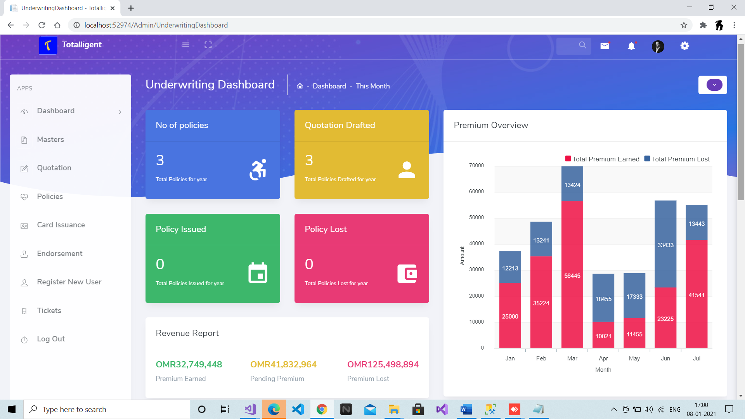

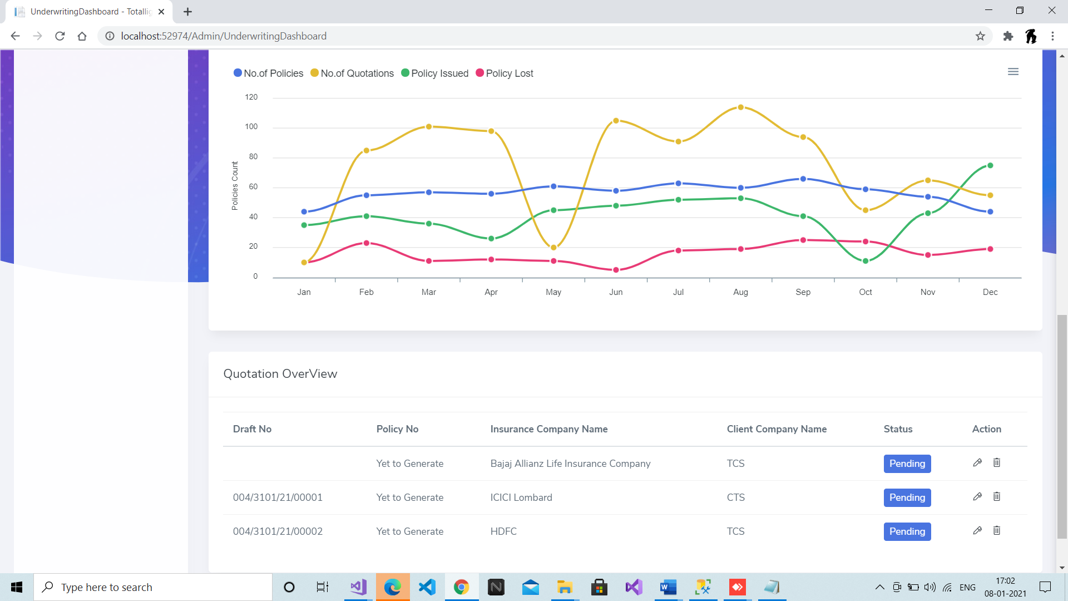

Master: 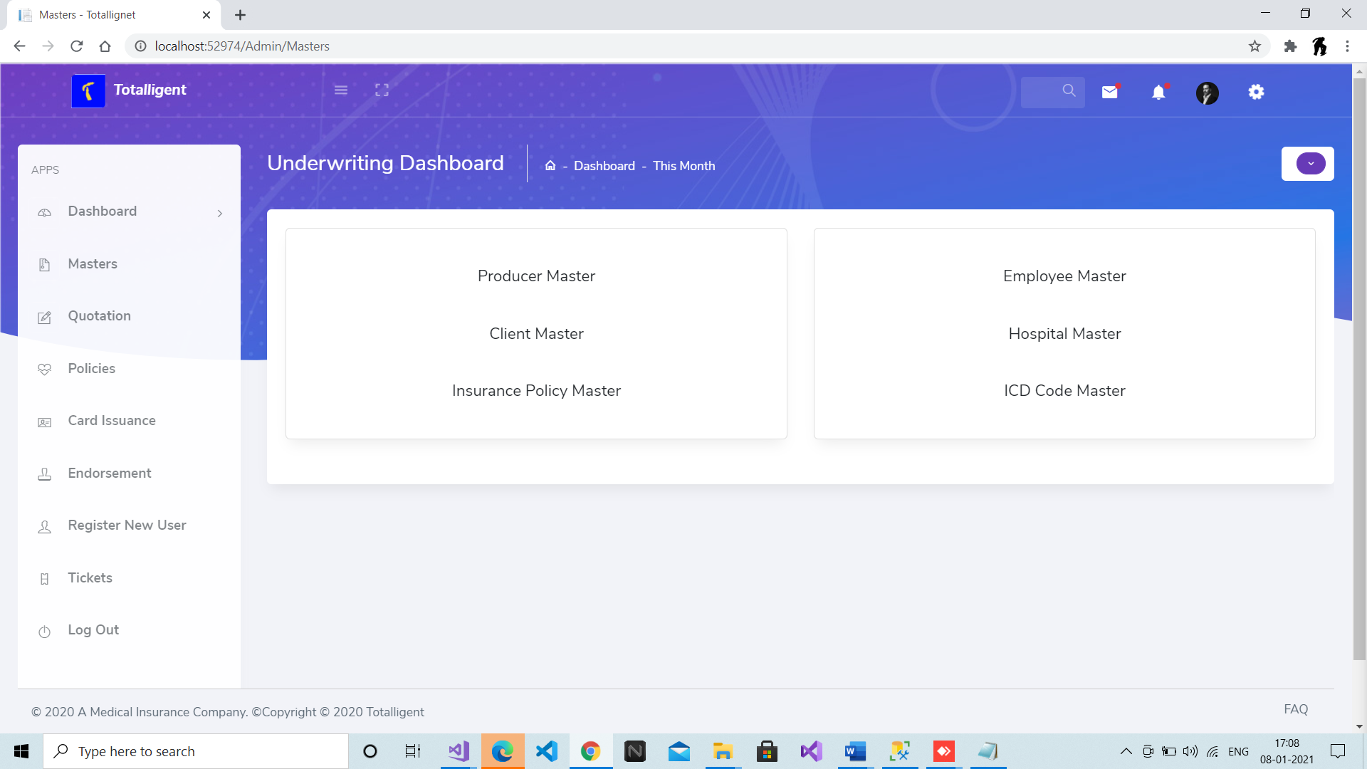

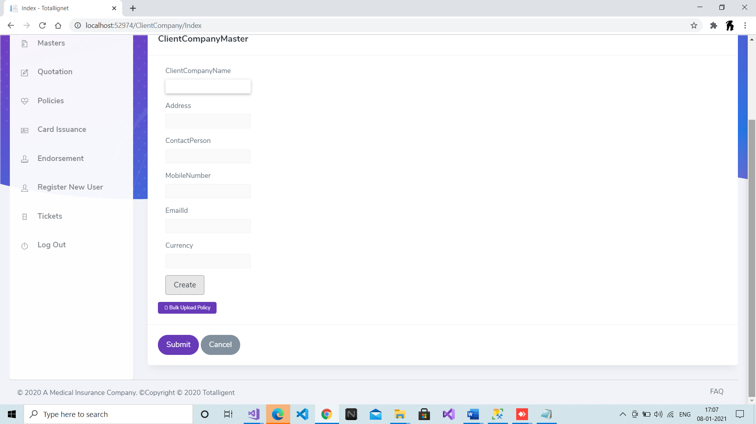

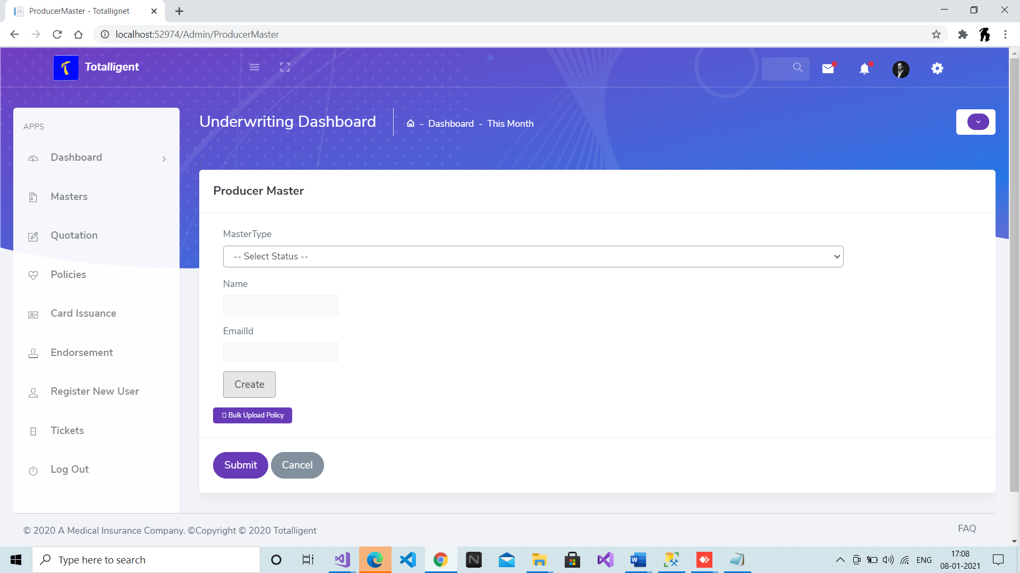

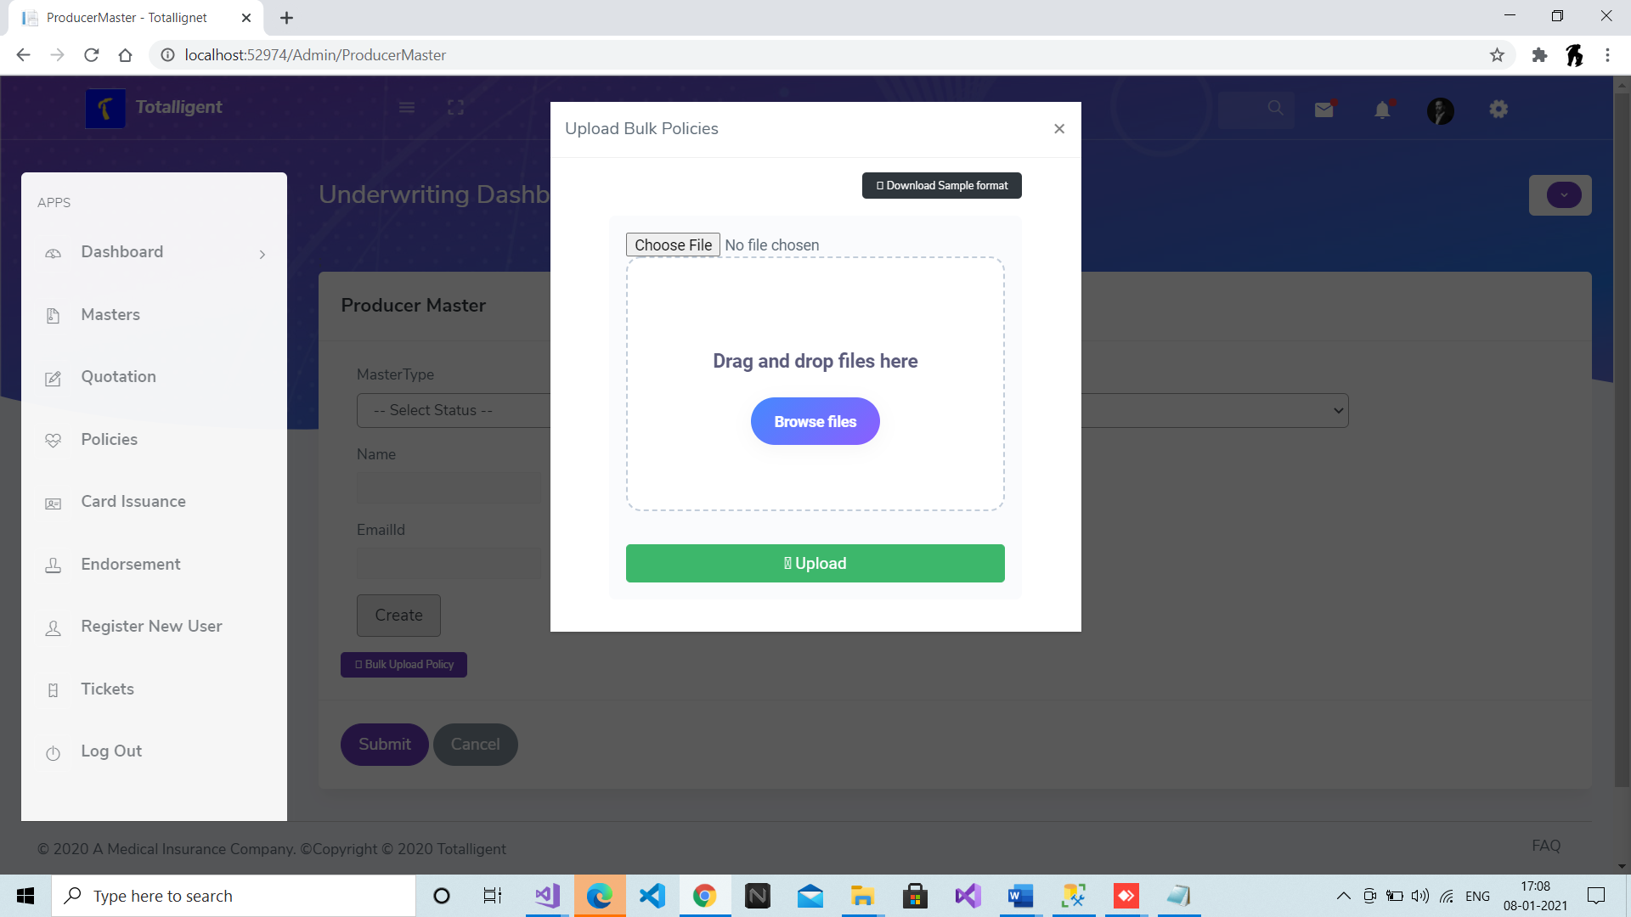

Quotation:

